Guidance Notes
Communities Leading Change is a creative way for individuals, groups and organisations to choose which projects in their locality they want funded. Anyone who lives in the District can bid for funding however it has to be used to benefit the area in which the PB event is aimed. There are two events happening in Newry Mourne and Down.
Event two is a district wide event aimed at Youth groups (aged 0- 24). There will be two chances to vote for these projects:

- Online Via Facebook 22 October – 19 November 2018
- Voting Event 24 November at 10am, venue tbc

Bidders will fill in a simple application form by 15 October 2018, once checked for safety, legality, and deliverability; your project team will be required to send in a photo/video/ other, to be uploaded online. Bidders will be encouraged to ask their friends and family to vote for their project, they will also be able to share the page/link for wider voting.

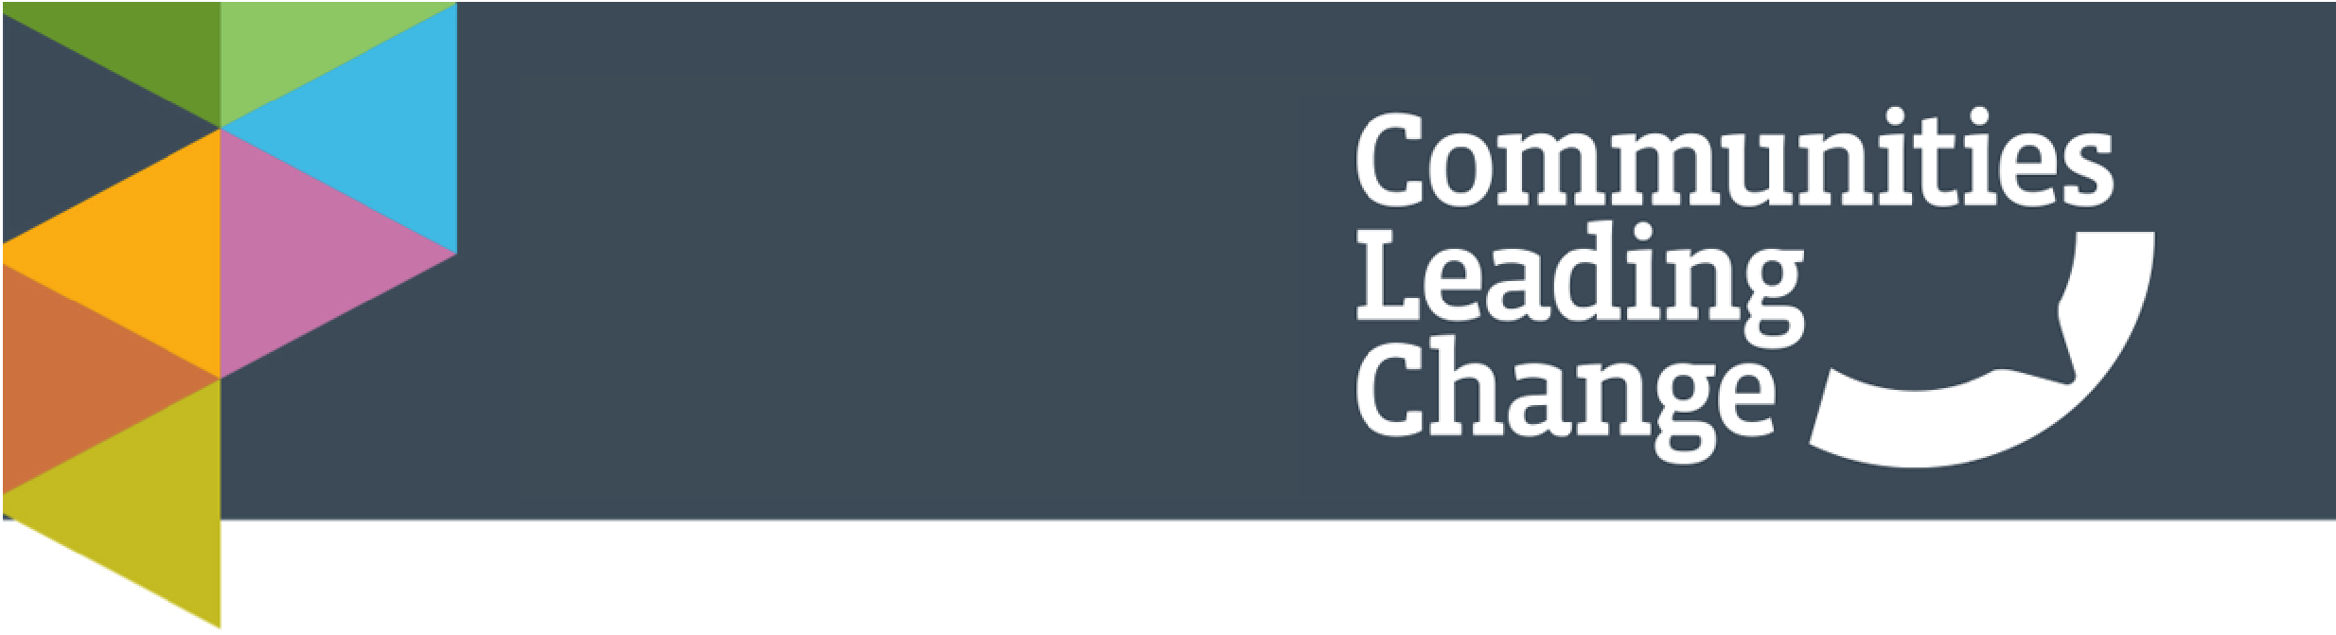
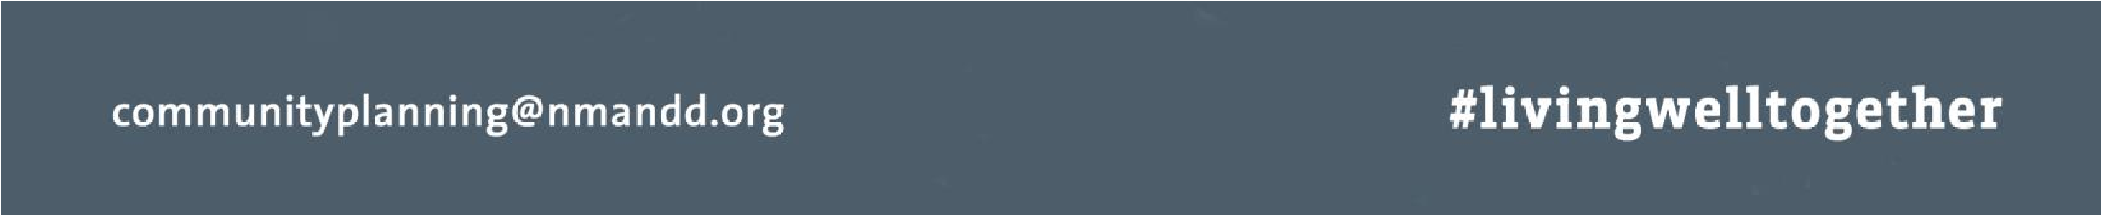
You / your project team will also be required to present your project at the voting event on 24 November. Those attending the event (the local community) will then vote for who they want the funding to be allocated to. You/a representative of your group must be free to attend the voting event at the specified time/day otherwise your application will be void.

If a group needs any assistance in the production of an online bid, please specify this under question 2E on the application form.

Important Dates
Application Opening | w/c 17 Sept 2018
Information Evening | w/c 08 October 2018
Close of applications | 15 October 2018
Feedback for applications | w/c 15 October 2018
Online Voting | 22 October – 19 November
District Wide Voting Event | 24 November 10am- 1pm
Update on Projects from successful bidders | March 2019

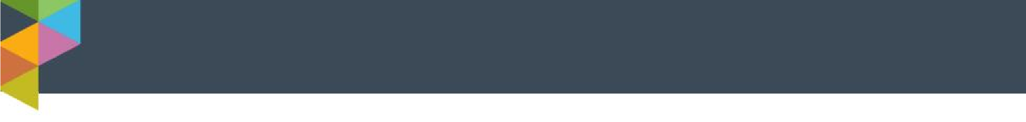
 | Eligibility Criteria
• | Any individual, community group or organisation can bid for funding up to £500. We will always receive more applications than we have funding for. Therefore not everyone will be successful. However there are a range of alternative funding sources that you may be able to access. Communities Leading Change partners will be available on the day to advise you.
• | If any person (s) is under the age of 18 a supporting adult should be available to help with the pitch and sign the application form.
• | Support will be available to complete the forms, deliver presentations and help with any queries or issues needed to make your bid.
• | Additional Support will be available on the day if you are unsuccessful in your bid.
• | Funding will only be allocated to projects delivered within the specified geography
• | Funding will only be allocated to non- profit organisations
• | You must be able to spend the funds within 6 months if successful.
• | You must be able to attend the voting event.
• | You must complete and return the form by post or email/face-face.
• | Funding applications will be subject to such other checks as are deemed necessary during the application process.
• | No audio visual presentation equipment will be available at the voting event but bidders are encouraged to be innovative in their bid.
• | Bid presentations are to be a Max 3 minutes.
• | Successful bidders are required to send a small paragraph on how their funding was spent – a template will be provided, this will be used in press releases and any PR activities to do with the event. Examples of information required: How many people participated, how it benefitted the local community, have any improvements been made as a result of this project, lessons learned and any feedback received.
• | Bidders consent to any photograph/ video footage being shared online by Newry, Mourne and  Down District Council website and social media and sharing with any Communities Leading Change partners for distribution on their websites and other media as appropriate to the campaign.

