Breakfast banana pops

Ingredients
150ml fat-free plain or flavoured yogurt
2 bananas
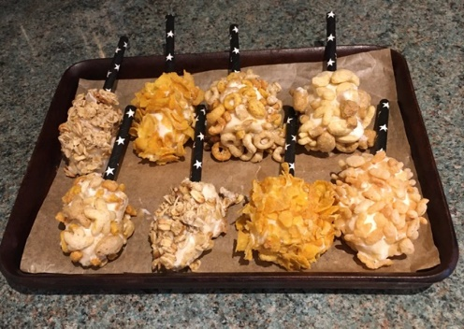
50g breakfast cereal, e.g. hoops, rice pops,
reduced-sugar granola, corn flakes
8 lolly sticks, paper straws or metal/wooden forks

Equipment
Baking tray, greaseproof paper, spoon, small bowl, vegetable knife/table knife, chopping board, small plastic bag, plate/bowl.

Method
- Line a baking tray with greaseproof paper.
- Spoon the yogurt into a small bowl.
- Peel and cut the bananas into quarters.
- Push a lolly stick, paper straw or fork into the bottom of the banana pieces.
- Place the breakfast cereal into a small plastic bag and lightly crush with your hands.
- Pour the crushed cereal onto a plate or bowl.
- Dip a banana piece into the yogurt. Roll it around so that it is evenly covered and thickly coated. Using a spoon might help with this.
- Roll the coated banana in the crushed cereal and place on the lined baking tray.
- Repeat with the remaining banana pieces.
- Eat and enjoy!

Top tip
- To make frozen Breakfast banana pops, freeze for at least an hour.

Recipe from Food – a fact of life.

