Classic fajitas

Ingredients
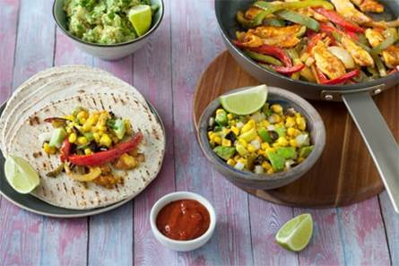
Fajitas
1 onion
1 red pepper
1 green pepper
500g chicken fillets or beef frying steak
Spray oil
1 sachet fajita seasoning mix
1 pack tortilla wraps
1 jar tomato salsa

Sweetcorn salsa
1 avocado
1 small can sweetcorn
1 lime
3 spring onions
2 x 15ml spoons coriander
1 x green chilli (optional)
1 x 15ml spoon black olives

Equipment
Vegetable knife, chopping board, red chopping board, large frying pan, wooden spoon, sieve or colander, juicer, small bowl, table spoon.

Method – fajitas
- Prepare the ingredients:
  - peel and slice the onion;
  - halve, deseed and slice the peppers.
- Cut the chicken or beef into strips, ideally on a red chopping board. Thoroughly wash and dry your hands after touching the raw meat.
- Heat a little spray oil in a frying pan and cook the chicken, or beef if using, over a medium/high heat until cooked through. Cut a piece of meat in half to check that no pink remains.
- Add the onion and peppers and cook for a further 5-10 minutes.
- Add the fajita seasoning mix and cook until the meat is brown and the vegetables are crunchy.
- Heat the tortillas:
  - In the microwave: Pierce the pack and place it in the microwave. Heat for 35 seconds on full power (800 watts). Open the pack and separate tortillas.
  - In the pan: Heat a pan and toast the tortillas for 5 seconds on both sides. Wrap in a tea towel to steam.
- Serve the chicken and peppers, the tortillas, the sweetcorn salsa and the tomato salsa on the table for everyone to make their own!

Method – sweetcorn salsa
- Prepare the ingredients:
  - peel and cube the avocado;
  - drain the can of sweetcorn;
  - cut and juice one half of the lime;
  - top, tail and slice the spring onion;
  - chop the coriander;
  - deseed and chop the green chilli, if using.
- In a small mixing bowl, add the avocado, sweetcorn, lime juice, spring onion, coriander and chilli, if using. Add the olives and stir.

Top tips
- Cut the avocado in half, remove the stone using a spoon and then peel away the skin. Lay the avocado half flat-side down on the chopping board, secure with a fork and then cut into cubes.
- Use a fork to secure the chilli on the board when chopping it. Wash your hands thoroughly after touching the chilli and do not touch your eyes, nose or mouth.
- Add reduced-fat grated cheese, black beans, lettuce and/or some guacamole!

Recipe kindly provided by Old El Paso, an Official Supporter of BNF Healthy Eating Week.

