Chunky chicken and potato soup

Ingredients
3 potatoes, such as Maris Piper or King Edward (approximately 400g)
2 leeks
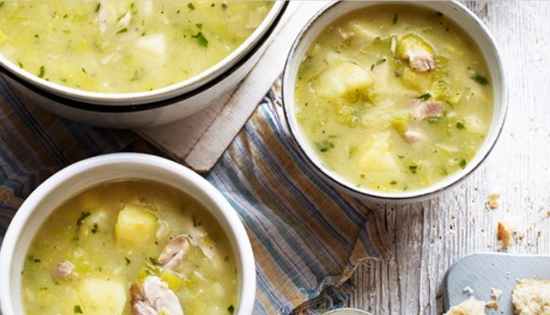
1 garlic clove
1 x 5ml spoon fresh or dried thyme
Spray oil
4 boneless chicken thighs, skin removed
20g butter/spread
750ml boiling water
1 reduced-salt chicken stock cube
2 x 5ml spoons plain flour
Black pepper

Equipment
Vegetable peeler, vegetable knife, chopping board, garlic press, medium/large saucepan, 2 x plates, mixing spoon, measuring jug, 2 x forks.

Method
- Prepare the ingredients:
  - peel and cut the potatoes into 2cm dice;
  - top, tail and slice the leeks thinly;
  - peel and crush the garlic clove;
  - chop the fresh thyme, if using.
- Heat the spray oil in the saucepan and cook the chicken for about 3-4 minutes and golden on both sides. Remove the chicken and place on a plate.
- Add the leeks and garlic to the saucepan and cook over a low heat in the butter/spread until soft, about 7 minutes.
- Boil the kettle and pour 750ml into a measuring jug. Stir in the stock cube to dissolve.
- Stir in the flour to the saucepan.
- Add the potatoes and chicken stock to the saucepan.
- Bring to the boil and then reduce to a simmer.
- Add the chicken and cook for about 10 minutes.
- Remove the chicken, place on a clean plate and shred with a fork. Check that no pink remains.
- Return the chicken to the pan.
- Add the thyme and season with black pepper.
Top tips
- Try using firm tofu (rather than silken) and a vegetable stock for a vegetarian alternative.
- Serve with freshly chopped parsley and crusty wholemeal bread.

Recipe kindly provided by the Agriculture and Horticulture Development Board (AHDB), an Official Supporter of BNF Healthy Eating Week.

