Fruitylicious apple and berry bars

Ingredients
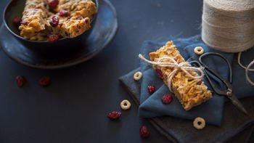
1 medium eating apple
140g multigrain breakfast hoops
115g self-raising flour
1 x 5ml spoon baking powder
85g dried berries, e.g. blueberries, cherries, cranberries
2 x 15ml spoons muscovado sugar
1 medium egg
150ml semi-skimmed milk
3 x 15 ml spoons light olive oil or sunflower oil

Equipment
Baking tray, baking parchment, vegetable knife, chopping board, large mixing bowl, measuring spoons, mixing spoon, small bowl, fork, measuring jug, cooling rack.

Method
- Preheat the oven to 200°C or gas mark 6.
- Line a 20cm x 25cm tin with baking parchment.
- Wash, core and finely chop the apple. No need to peel!
- Place 100g of the hoops in a large mixing bowl along with the flour, baking powder, dried fruit, sugar and apple.
- Stir together until well combined.
- Crack the egg into a small bowl and beat with a fork.
- Add the milk, beaten egg and oil to the large bowl and mix.
- Pour the mixture into the prepared tin and spread evenly.
- Sprinkle over the remaining hoops and lightly press them into the mixture.
- Bake for 25 minutes until golden and just firm.
- Leave to cool for a few minutes then lift out onto a cooling rack to cool completely.
- Use a knife cut into 10 bars.

Top tips
- Use sultanas, raisins, chopped dried apricots or mixed dried fruit instead of dried berries.
- Try chopped pear in place of the apple. Just wash and chop, no need to peel!

Recipe kindly provided by Nestlé Cereals, an Official Supporter of BNF Healthy Eating Week.

