Noodles in a jar
Ingredients
50g dried noodles
1 spring onion
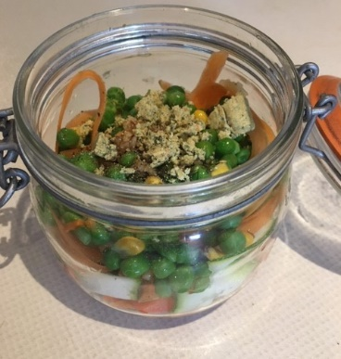
¼ red, yellow or orange pepper (deseeded)
¼ courgette
1 small carrot
2 x 15ml spoons frozen peas
2 x 15ml spoons frozen sweetcorn
½ clove garlic
1 lime
Pinch of chilli flakes
Pinch of ground ginger
2 x 5ml spoons light soy sauce
½ reduced-salt stock cube or ½ x 5ml spoon yeast extract
Black pepper
150ml boiling water

Equipment
A glass jar or plastic pot with a lid, vegetable knife, chopping board, vegetable peeler, garlic press, zester/grater, juicer, measuring jug.

Method
- Break up the noodles into the clear jar or plastic pot.
- Prepare the ingredients:
  - top, tail and finely slice the spring onion;
  - dice the pepper;
  - slice the courgette into ribbons using a vegetable peeler;
  - peel, top, tail and slice the carrot into ribbons, using a vegetable peeler;
  - peel and crush the garlic clove;
  - zest half of the lime;
  - cut the lime in half and juice one half.
- Add the spring onion, pepper, courgette, carrot and half the crushed garlic to the jar/pot.
- Add the zest and the lime juice.
- Add the frozen peas and sweetcorn.
- Add the chilli flakes, ground ginger, and ½ stock cube or yeast extract.
- Season with black pepper.
- Boil the kettle.
- Pour over 150ml boiling water, cover and leave for five minutes.
- Stir and enjoy!

Top tips
- Ensure that the glass jar or plastic pot is heat proof.
- Be aware of the boiling water and use an oven glove when stirring the noodles if need be.
- Use a variety of vegetables – whatever you have in your fridge or freezer!
- If not eating straight away, store the noodles in the fridge and add the boiling water just before you want it.

Recipe from Food – a fact of life.

