Tasty tuna pasta

Ingredients
2 spring onions
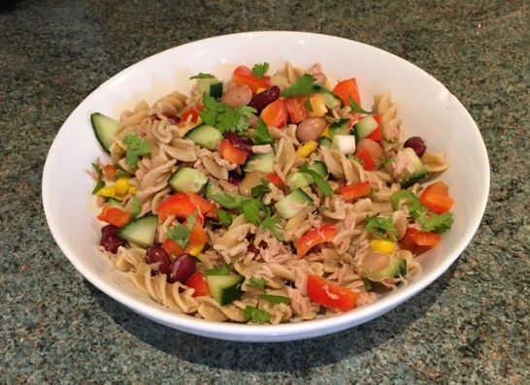
4 x 15ml spoons canned sweetcorn (drained)
¼ cucumber
½ red, yellow or orange pepper (deseeded)
200g can mixed beans (drained and rinsed)
1 small can tuna in water (drained)
200g cooked wholewheat pasta, e.g. fusilli or bow-tie pasta (farfalle)
1 x 15ml spoon reduced fat dressing
A few sprigs of fresh coriander

Equipment
Chopping board, kitchen scissors, measuring spoons, table knife, can opener, sieve, small bowl, fork, mixing bowl, mixing spoon.

Method
- Prepare the vegetables:
  - top, tail and snip the spring onions, using scissors;
  - chop the cucumber into small pieces;
  - chop or snip the pepper into small pieces.
- Place the tuna in a small bowl and break up gently with a fork.
- Place the vegetables, beans, tuna and pasta in a large mixing bowl.
- Pour over the dressing.
- Stir everything together.
- Snip coriander over the salad, using scissors.
- Serve.

Top tips
- Use different vegetables or fruit, e.g. French beans, mango.
- Add strips of cooked chicken, ham or beef.
- Use canned salmon or crab instead of tuna.

Recipe from Food – a fact of life.

