Veggie fruity burgers

Ingredients
5 medium carrots
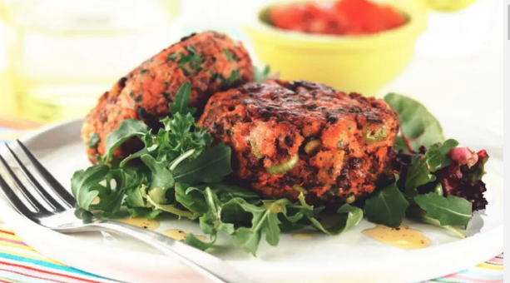
50g fresh breadcrumbs (approximately
2 slices bread)
6 dried apricots
50g sultanas
4 spring onions
1 orange
1 x 5ml level spoon yeast extract
175g Quorn Mince
1 x 5ml spoon dried chilli flakes
Spray oil

Equipment
Vegetable knife, chopping board, zester/grater, large mixing bowl, potato masher, measuring spoons, mixing spoon, grill tray, flipper (fish slice).

Method
- Prepare the ingredients:
  - wash and slice the carrots (no need to peel);
  - blitz the bread in a food processor to make crumbs, if necessary;
  - finely chop the apricots;
  - finely chop the sultanas;
  - Top, tail and finely slice the spring onions, including the green part;
  - zest the orange.
- Boil the carrots until soft. Drain using a colander.
- In a large mixing bowl, mash the carrots.
- Stir through the yeast extract so that it melts.
- Add the Quorn Mince, breadcrumbs, apricots, sultanas, spring onions, orange zest and chilli flakes.
- Mix well.
- Form the mixture into 10-12 even sized burgers using your hands. Alternatively, use a suitable sized pastry cutter as a mould.
- Pre-heat the grill.
- Place the burgers on a grill tray and spray with spray oil.
- Grill the burgers for 10-12 minutes on a medium- heat, turning halfway for even browning. Spray with oil again once turned over.

Top tips
- Serve on a wholemeal roll with dark green leafy vegetables, such as spinach or kale, and sliced tomatoes. Add a portion of mixed salad and a drink for a complete meal.
- If using fresh Quorn Mince, the burgers can be frozen after step 7. If using frozen, the burgers can be frozen once they have been cooked and cooled. To re-heat, defrost thoroughly, cover with tin foil and heat in the oven until piping hot.
Recipe kindly provided by Quorn Foods, an Official Supporter of BNF Healthy Eating Week

